Project Report
Sustainable Waste Management Assistant Using Generative AI
(WasteGuide AI)

1. Introduction
1.1 Project Overview
WasteGuide AI is a full-stack, production-quality web application that helps citizens identify waste items, understand proper disposal methods, learn recycling procedures, locate nearby waste collection centers, and visualize personal waste-management statistics. It demonstrates smart-city concepts, environmental sustainability, responsible waste disposal, AI-assisted civic services, and modern full-stack software engineering.
1.2 Purpose
The purpose of WasteGuide AI is to reduce improper waste disposal and hazardous-waste mishandling by giving citizens an instant, AI-powered way to classify any waste item and receive clear, actionable disposal and recycling guidance — while also helping local bodies and citizens track waste trends through analytics and locate the correct collection center on a map.
2. Ideation Phase
2.1 Problem Statement
Citizens often lack awareness of how to correctly classify and dispose of waste items (plastic, e-waste, hazardous, medical, etc.), leading to improper disposal, environmental hazards, and inefficient recycling in smart cities. Existing solutions — municipal pamphlets, generic search engines, and static waste-sorting apps — do not combine real-time classification with location-based center mapping and personal tracking.
2.2 Empathy Map Canvas
Persona: An urban citizen encountering an unfamiliar or hazardous waste item at home.
Quadrant | Observations
SAYS | "I don't know if this can be recycled." "Where do I even throw this battery?" "I don't want to just Google and guess."
THINKS | Worried about harming the environment; unsure if the local center accepts this item; assumes it's someone else's job to know this.
DOES | Searches the internet for generic articles, asks family/friends, or simply throws the item into a regular bin out of convenience.
FEELS | Confused, mildly guilty, and rushed — wants a fast, trustworthy answer rather than a 10-minute search.
2.3 Brainstorming
Ideas generated during brainstorming, and the ones selected for the MVP:
- AI chatbot that answers free-form waste questions — parked for a future release (kept the structured classify flow for MVP reliability).
- Barcode/image-based scanning — parked for future release; text-based item entry chosen for MVP simplicity and speed.
- AI-powered text classification returning structured JSON (category, recyclability, hazard level, disposal & recycling steps, eco tip) — selected.
- Personal dashboard with recycling analytics to encourage habit-building — selected.
- Map of nearby waste-collection centers with category-based markers — selected.
- Gamified rewards/points for recycling — parked for future release.
3. Requirement Analysis
3.1 Customer Journey Map
Stage | User Action / Touchpoint | Thoughts & Emotions
Awareness | Encounters an unfamiliar/hazardous item at home | "I'm not sure how to dispose of this." — Confused
Consideration | Opens WasteGuide AI, types the item name and taps Scan | "Let's see if this actually helps." — Curious, hopeful
Action | Reads the AI-generated classification, hazard warning, and disposal/recycling steps | "That's clear and specific." — Relieved, confident
Retention | Checks the Dashboard and History to track scanning habits over time; opens Map to find a center | "I'm actually being more responsible." — Satisfied, motivated
3.2 Solution Requirement
Functional Requirements:
- Accept a waste item name and return an AI-generated classification (category, recyclable, hazard level, disposal steps, recycling steps, eco suggestion).
- Persist every scan to Firestore and allow viewing, searching, filtering, sorting and deleting history.
- Compute and display analytics: total scans, recyclable/hazardous counts, recycle %, category breakdown, and last-7-days trend.
- Display nearby waste-collection centers on an interactive map with category-based markers and directions.
Non-Functional Requirements:
- Response time under 3 seconds for AI classification.
- Responsive design across desktop, laptop, tablet and mobile, with dark-mode support.
- Graceful error handling for no internet, API timeouts, invalid input, and Firestore failures.
- Secure handling of API keys and Firebase credentials (never exposed to the client); input sanitization on all endpoints.
3.3 Data Flow Diagram
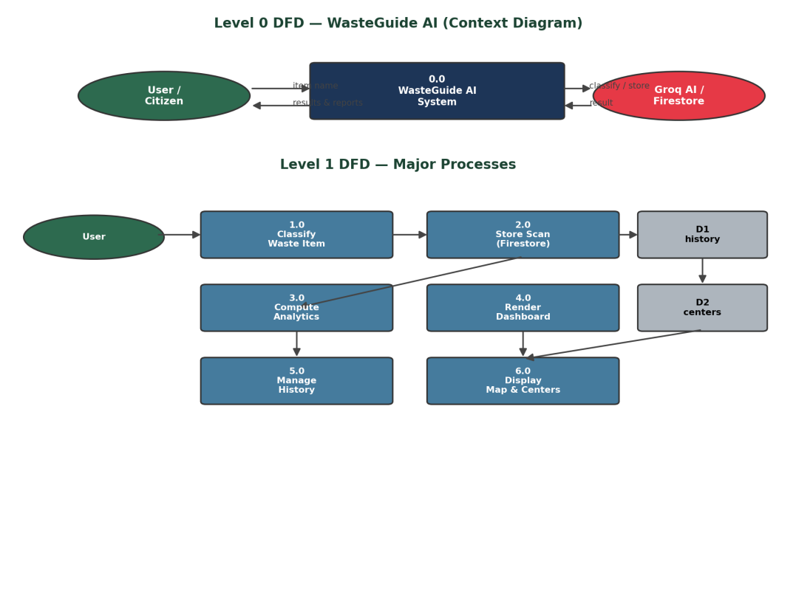
Figure: Level 0 and Level 1 Data Flow Diagrams for WasteGuide AI
3.4 Technology Stack
Layer | Technologies
Frontend | React.js, Vite, React Router, Axios, Tailwind CSS, Chart.js, Leaflet.js, React-Leaflet
Backend | Python, Flask, Flask-CORS, Firebase Admin SDK, Requests
Database | Firebase Firestore
AI | Groq API — model: llama-3.3-70b-versatile
Maps | OpenStreetMap, Leaflet.js
Version Control | Git
Deployment | Frontend: Vercel/Netlify · Backend: Render · Database: Firebase
4. Project Design
4.1 Problem – Solution Fit
Customer Segment: Urban citizens, households, students and municipal staff who need quick guidance on identifying and disposing of waste. Jobs-to-be-done: quickly identify a waste item's category, learn safe disposal/recycling steps, and locate the nearest collection center. Root Cause: lack of a centralized, AI-powered tool combining classification, guidance and location services. Your Solution: WasteGuide AI — instant Groq-powered classification, disposal/recycling guidance, personal analytics, and a collection-center map. (Full 10-box canvas provided in the separate Problem–Solution Fit document.)
4.2 Proposed Solution
Parameter | Description
Problem Statement | Citizens lack awareness of how to correctly classify and dispose of waste, leading to improper disposal and inefficient recycling.
Idea / Solution | An AI web app (Groq LLaMA 3.3-70B) that classifies waste items and returns structured disposal/recycling guidance, with dashboard analytics and center mapping.
Novelty / Uniqueness | Combines real-time GenAI classification with center mapping and personal analytics in one platform; forces strict JSON output for consistency.
Social Impact | Encourages responsible disposal, reduces hazardous-waste mishandling, and supports smart-city sustainability goals.
Business Model | Freemium for citizens; premium tier for municipal bodies/housing societies; potential eco-brand partnerships.
Scalability | Modular Flask services and component-based React frontend scale to new categories, languages, cities, and IoT-enabled smart bins.
4.3 Solution Architecture
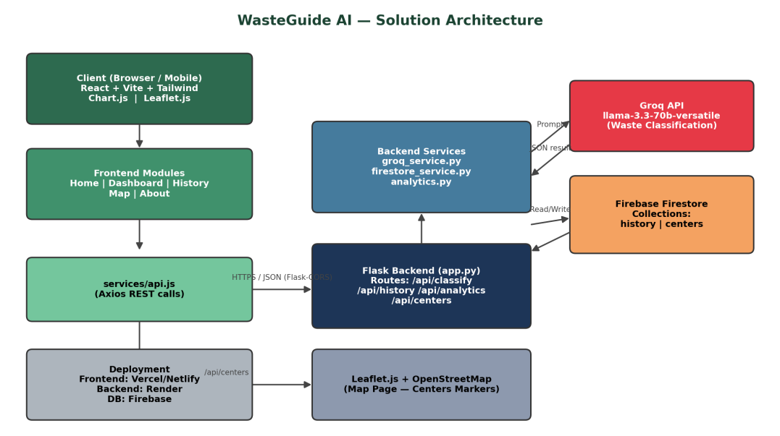
Figure: End-to-end solution architecture of WasteGuide AI
5. Project Planning & Scheduling
5.1 Project Planning
The WasteGuide AI backlog was organized into 22 user stories across 4 sprints, covering Waste Classification, Data Storage, Dashboard & Analytics, History Management, Map Integration, Error Handling, Testing & Documentation, and Deployment.
Sprint | Key Epics | Story Points
Sprint-1 | Waste Classification, Data Storage (Firestore) | 12
Sprint-2 | Dashboard & Analytics | 15
Sprint-3 | History Management, Map & Collection Centers | 14
Sprint-4 | Error Handling, Testing & Documentation, Deployment | 13
Total Story Points = 54, across 4 Sprints → Velocity = 54 / 4 = 13.5 Story Points per Sprint.
6. Functional and Performance Testing
6.1 Performance Testing
Key test scenarios validated the Groq-based classification pipeline, Firestore storage, analytics, history, and map rendering:
Test ID | Scenario | Expected Result
FT-02 | Waste Classification (Groq API) | Correct JSON classification generated and displayed within the Waste Result Card
FT-04 | Firestore Save Check | Scan result correctly saved to the 'history' collection with a timestamp
FT-06 | Analytics Calculation | Correct totals, recycle %, hazard % and last-7-days data returned
PT-01 | Response Time Test | Classification result returned in under 3 seconds
PT-02 | API Speed / Concurrency Test | API handles concurrent requests without significant slowdown
Full test scenarios and results are documented in the separate Functional & Performance Testing and UAT Execution & Report Submission documents.
7. Results
7.1
https://waste-guide-ai-lcoa.vercel.app
8. Advantages & Disadvantages
Advantages:
- Instant, AI-powered waste classification without manual lookup.
- Combines classification, analytics, and location-based center mapping in one platform.
- Encourages responsible disposal habits through personal tracking and visualization.
- Modular architecture that scales easily to new categories, cities, and languages.
Disadvantages:
- Classification accuracy depends on the underlying Groq model and may misjudge ambiguous or multi-material items.
- Requires an active internet connection; no offline support currently.
- Waste-collection-center data must be manually seeded/maintained for accuracy in each city.
9. Conclusion
WasteGuide AI successfully demonstrates how Generative AI can be applied to a real civic problem — improper waste disposal — by combining instant AI classification, actionable guidance, personal analytics, and location-based services into a single, easy-to-use web application. The project fulfils its goal of promoting responsible, informed waste disposal while showcasing modern full-stack engineering practices.
10. Future Scope
- Image/barcode-based waste scanning using a vision-capable model.
- User accounts (Firebase Authentication) for cross-device personalized history.
- Mobile app and IoT-enabled smart-bin integration.
- Multi-language support and integration with municipal waste-collection scheduling.
- Gamified rewards to further encourage recycling habits.
11. Appendix
Source Code: [GitHub repository link]
Dataset Link: Not applicable — WasteGuide AI uses real-time AI classification via the Groq API rather than a static training dataset. Seeded/dummy data is used for waste-collection centers.
GitHub & Project Demo Link: [GitHub repository link] · [Live demo / deployed application link]

